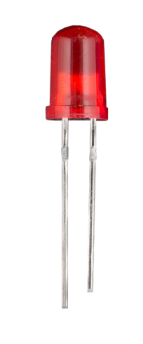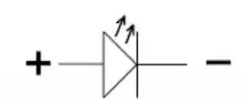
Symbol of LED
LED Light Emitting Diode
-
+
Shorter Leg Negative
Longer Leg Positive
· An LED is a small light that lights up with electricity.
· The longer leg is the positive side (anode).
· The shorter leg is the negative side (cathode).
· A resistor is necessary to limit current when turning on the LED.
· Connecting an LED directly to a battery can damage it.
· LEDs use less energy than regular light bulbs.
· They can last many years—often tens of thousands of hours.
· Commonly found in toys, remote controls, and decorations.
· Available in various colors, like red, green, and blue.
· Used to indicate when something is on or working.

Resistance

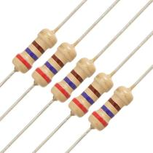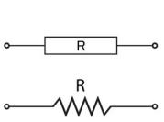

Resistance (No + OR -)

· Resistance is a measure of how much a material opposes the flow of electricity.
· It is measured in ohms (Ω).
· Resistors are components that create resistance in a circuit.
· They help limit the current flowing through an LED or other devices.
· Using a resistor prevents damage to components by controlling the amount of electricity.
· Resistors can be found in various shapes and sizes, often color-coded to indicate their value.
· They are essential in electronics for protecting sensitive parts and ensuring proper functioning.
· Different types of resistors include fixed, variable, and potentiometers.
· Resistance affects how bright an LED lights up—higher resistance means dimmer light.

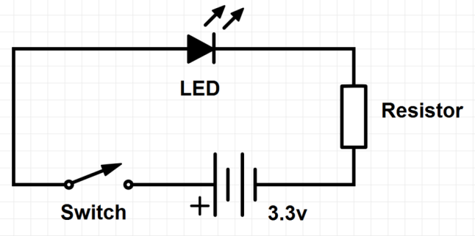
9V BAT
A circuit using an LED, resistor, battery (9V), and a switch:
Components:
- LED: The light-emitting diode that will light up.
- Resistor: Limits the current to protect the LED.
- 9V Battery: Provides power to the circuit.
- Switch: Allows you to turn the circuit on or off.

How It Works:
Circuit Setup:
  - Connect the longer leg (anode) of the LED to one end of the resistor.
  - Connect the other end of the resistor to the positive terminal of the 9V battery.
  - Connect the shorter leg (cathode) of the LED to one terminal of the switch.
  - Connect the other terminal of the switch to the negative terminal of the battery.
Turning On the Circuit:
  - When you flip the switch to the "on" position, electricity flows from the positive terminal of the battery, through the resistor, then through the LED, and finally back to the negative terminal of the battery.
  - The resistor limits the current so that the LED does not get too much electricity, which helps prevent damage.
Result:
  - The LED lights up when the switch is on, indicating that the circuit is complete and functioning.

Summary:
- This simple circuit shows how an LED, resistor, battery, and switch work together. The resistor is crucial for protecting the LED, while the switch lets you control when the LED is on or off.

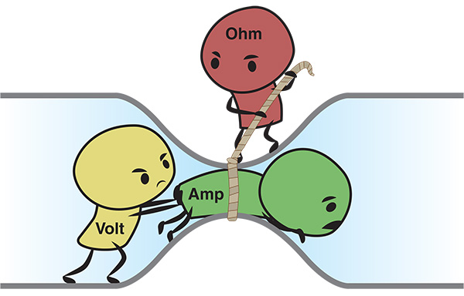

Ohm's Law:
- Formula: V=I×RV = I \times RV=I×R
(Where VVV is voltage, III is current, and RRR is resistance)

Key Relationships:
- Inversely Proportional:
  - When you increase resistance in a circuit, the current flowing through the circuit decreases. This means that as resistance goes up, current goes down if the voltage stays the same.
- Directly Proportional:
  - When you increase voltage, the current increases. This means that as voltage goes up, current goes up if the resistance stays the same.

Summary:
- Ohm's Law shows how voltage, current, and resistance are related.
- More resistance means less current (inversely proportional).
- More voltage means more current (directly proportional).
This relationship helps in designing and understanding electrical circuits!

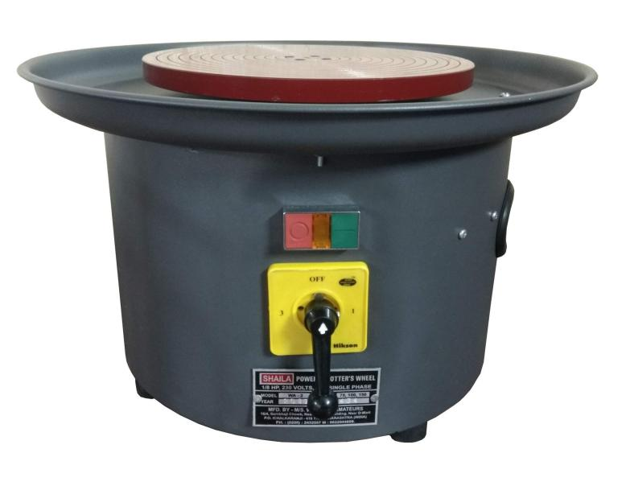
Pottery

Prepare Clay for Pottery:
Gather Soil: Start with normal garden or farm soil.
Remove Debris: Remove any tree branches, leaves, and stones from the soil to ensure it's clean.
Strain the Soil: Use a sieve or mesh to strain the soil. This helps to separate smaller particles and eliminate larger debris.
Add Water: Gradually add water to the strained soil to make it pliable and form a clay-like consistency.
Knead the Clay: Knead the mixture until it’s smooth and free of air bubbles. This helps to improve its texture and workability.
Shape and Use: Once the clay is ready, you can use it on a pottery wheel or for hand-building pottery items.

Summary:
An electric pottery wheel allows for easier and more consistent shaping of clay compared to a manual wheel. After preparing the clay from garden soil, you can create beautiful pottery with less effort!

3D printer
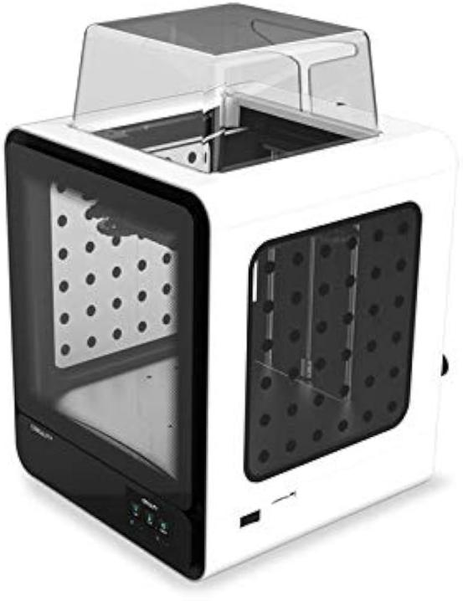

Understanding 3D Printing
3D printing is a process that creates three-dimensional objects by layering materials based on a digital design.

Three Dimensions:
- X-Axis: This represents the horizontal direction (left to right).
- Y-Axis: This represents the depth (front to back).
- Z-Axis: This represents the vertical direction (up and down).

How 3D Printing Works:
- Layering Process: The printer moves along the X, Y, and Z axes to build objects layer by layer:
  - X and Y Movements: Control the position of the nozzle as it traces the shape of each layer on the print bed.
  - Z Movement: Raises the nozzle after each layer is completed, allowing the next layer to be added on top.

Basic Parts of a 3D Printer:
- Filament: The material used to create 3D objects, commonly made from PLA or ABS. It comes in spools and is fed into the printer.
- Print Bed: The flat surface where the 3D object is built, often heated to improve adhesion.
- Extruder: Melts the filament and deposits it layer by layer to form the object.
- Nozzle: The tip of the extruder that releases the melted filament.
- Frame: Holds all the parts of the printer together.

Temperature and Quality:
- Melting Temperature: A typical temperature for melting filament is around 200°C. If the filament is heated beyond this temperature, it can degrade, causing issues like bubbling or brittleness.

Design with Tinkercad:
- Tinkercad: An online application for designing 3D models. It's user-friendly and allows easy creation and modification of shapes, which can be exported for 3D printing.

Summary:
3D printing uses the X, Y, and Z axes to create three-dimensional objects by layering materials. Key components include filament, print bed, extruder, nozzle, and frame. Understanding these elements and dimensions is essential for creating accurate and high-quality 3D prints!

